**SQL Module 10 Challenge Worksheet**

The Challenge Activity for this module asks you to answer the questions below. Use this space to record your responses. Then save and submit this document to Canvas as instructed in your online classroom.

This challenge is going to test your ability to create wildcards, as well as clean and combine data. You will be wrapping up this lesson using the employee demo database for query building and data cleaning. Remember to go back and review any areas that you are unclear about before moving on through the challenge.

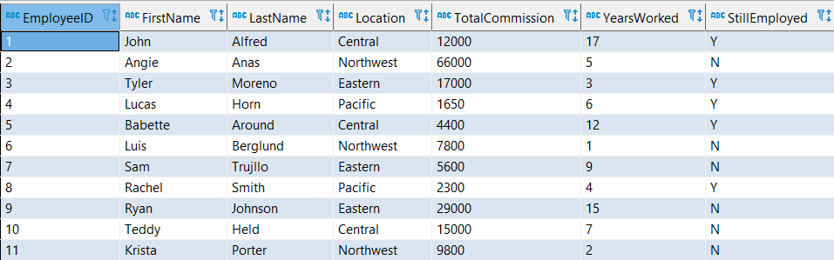

\*For a downloadable version of the database table, use the file provided in this Challenge in your online classroom.

Answer the following questions and queries, to successfully complete this challenge. Good luck!

**Instructions:** Follow the steps below to complete this challenge.

1. You want to combine the employee's first name and last name to create one column. Include an alias condition for EmployeeName. Using [myCompiler](https://www.mycompiler.io/new/sql) to complete the query below and include a space between each column:

Alternative Text: Image that shows a query with the following: 
SELECT ______(__________, "", __________) ____ EmployeeName
From employee

Insert your SQL query here:   
SELECT CONCAT(FirstName, ‘ ‘, LastName) AS EmployeeName  
FROM employee;

1. Create a query that will pull all records from the employeename column that start with the letters ‘ang’.

[Insert your SQL query here.]   
  
SELECT EmployeeName  
FROM employee   
WHERE EmployeeName LIKE 'Ang%';  
  
--(The downloadable database doesn’t seem to support ILIKE, so the last clause can be better written as WHERE EmployeeName ILIKE ‘ang%’;

1. Create a query that will pull all records that include any value that has the characters ‘bet’.

[Insert your SQL query here.]   
--Question says all records including any value so we need to look at Location as well  
SELECT \*  
FROM employee   
WHERE EmployeeName LIKE '%bet%' OR Location LIKE '%bet%';

1. Create a query of all the employees who are in Central, Northwest, or Pacific locations using only one operator.

[Insert your SQL query here.]   
SELECT \*  
FROM employee   
WHERE Location IN ('Central', 'Northwest', 'Pacific');

1. Create a query that will change location to all uppercase and call the new column ‘upperlocation’.

[Insert your SQL query here.   
SELECT UPPER(Location) AS upperlocation  
FROM employee;

1. Create a query that will remove all spaces from the beginning of the FirstName column. Call this column ‘firstnamenospaces’.

[Insert your SQL query here.]   
SELECT LTRIM(FirstName) AS firstnamenospaces  
FROM employee;

Challenge Questions

1. What wildcard will allow you to search for only specific characters within a value?

[Insert your response here.]   
The underscore (\_) wildcard permits searching for only specific specific characters within a value

1. What operator allows you to perform the same actions as the OR operator with less conditions?

[Insert your response here.] The IN(‘value1’,’value2’,’valuen’…) operator allows you to perform the same function as repeated OR operators